**The dynamics of online opinion formation: Polarization around the vaccine development for COVID-19**

Gaurav Jain, Avinash Bapu Sreenivas, Samrat Gupta

*Indian Institute of Management Ahmedabad, India*

# **Abstract**

According to the World Health Organization (WHO), social media-induced polarization caused due to the spread of misinformation related to the efficacy and side effects of a COVID-19 vaccine is potentially leading to *vaccine hesitancy,*one of the top ten threats to global health. In this study, we investigate the dynamics of social media polarization around COVID-19 vaccine which could be one of the causes of vaccine hesitancy. We use a simulation-based model of dynamical co-evolution in adaptive networks wherein interacting individuals influence each other’s opinions to arrive at a final network state. The opinion formation model simulates the temporal dynamics of social media polarization on the comments posted on different COVID-19 vaccine-development-related YouTube videos. The experimental results suggest that the degree of polarization in the online discourse, as measured by the time taken to form consensus, increases with recency in time. This finding significantly contributes to the highly contested debate around whether the flow of information on social media fosters or counteracts polarization.

**Keywords**: Polarization; COVID-19 pandemic; COVID-19 vaccine; Online opinion formation; Consensus formation; Social media.

# **Introduction**

COVID-19 was not only declared as a pandemic but was also termed as an “infodemic” by the United Nations[1]. COVID-19 led to the creation of enormous information on the web. For instance, there were more than 8000 papers in PubMed that included the word “COVID-19” by 30th April 2020 (Gonzalez-Padilla 2020). In addition to the rapid spread of the coronavirus, the information (and misinformation) on social media about the virus spread equally rapidly thus creating a panic in the society (Depoux et al. 2020; Laato et al. 2020). The panic created by social media was more contagious than the virus itself (Depoux et al. 2020; Wilson and Chen 2020). This unprecedented spread of information (and misinformation) influenced our society’s response to the virus[2] (Papakyriakopoulos, Medina Serrano and Hegelich 2020). As there was no scientific and social knowledge about the origin and the impact of COVID-19, many conspiracy theories emerged and spread quickly while claiming to provide credible explanations to the impact and the cure of the virus (Shahsavari et al. 2020). Public belief in these conspiracy theories prospectively predicted a resistance to the preventive measures and vaccination (Romer and Jamieson 2020). These conspiracy theories, coupled with the partisan differences, led to polarization in the society (Bail et al. 2018). For example, prominent republican government officials in the US, including the outgoing President Trump, have sent conflicting messages saying that the crisis caused by the coronavirus is less severe, but the Democrats emphasized the grave dangers of the pandemic[3]. Moreover, the partisan media have echoed this divide thus causing differences between the right and left leaning people to the extent that it could have far reaching impacts on human health and the economy(Allcott et al. 2020). These biased media opinions spread rapidly over social media and led to echo chamber effect whereby the individuals who were exposed to the opinions, beliefs and attitudes consistent to their own became polarized (Justwan et al. 2018).

In general, access to unsupervised social media usage allows individuals to share content without any editorial review and users can self-select the content that may contribute to ideological isolation (Puri et al. 2020). In the context of coronavirus, anti-vaccination messaging on social media has raised considerable public health concerns, misinformation regarding the medical composition and adverse effects of vaccination potentially leading to *vaccine hesitancy*, a patient level reluctance to receive vaccines (Puri et al. 2020). Due to the continued resurgence of vaccine preventable diseases, WHO has included vaccine hesitancy as one of the top ten threats to global health in 2019 (Puri et al. 2020). Misinformation and rumors related to COVID-19 vaccination on social media platforms started eroding the public confidence well before the release of an effective COVID-19 vaccine (Donovan 2020; Puri et al. 2020). For example, in India, leader of one political party (Samajwadi party)[4] has termed a COVID-19 vaccine, approved for emergency use by the Indian Council for Medical Research as the ruling party’s (BJP’s)[5] vaccine hence casting doubts in the minds of his followers about the efficacy of the vaccination and eventually leading to polarization between the followers of these political parties. This polarization has led to vaccine hesitancy among Indian masses to some extent (Khan et al. 2020). Another example is that of the outgoing US President Trump who repeated the debunked theory that vaccines cause autism while communicating that he slowed his son Barron’s vaccination schedule[6]. Research around the propagation of vaccine content on social media shows that the anti-vaccine content garners more user engagement than the neutral content (Blankenship et al. 2018; Puri et al. 2020). Some of the examples are:

1. Analysis of tweets between 2010 to 2016 containing the hashtag “vaccine” found that the anti-vaccine tweets were 4.13 times more likely to be retweeted than the neutral tweets (Blankenship et al. 2018; Puri et al. 2020).
2. Analysis of 150 Instagram posts containing the hashtag “HPV” suggested that the anti-vaccine posts had a significantly higher number of likes as compared to the neutral posts (Basch and MacLean 2019; Puri et al. 2020).
3. Another related research on 87 YouTube videos containing “vaccine safety” and “vaccines and children” in 2017 showed that 65% of the videos expressed an anti-vaccine sentiment (Basch et al. 2017; Puri et al. 2020).
4. Analysis of the top YouTube videos containing “COVID-19” and “coronavirus” identified that 27.5% of videos contained non-factual data around the disease but garnered over 60 million views (Li et al. 2020; Puri et al. 2020).

Anti-vaccine groups use different methods like bots and trolls that generate anti-vaccination messages in social network sites to quickly spread their messages arguing the possible harmful effects and distrust of pharmaceuticals (Ortiz-Sánchez et al. 2020). As more and more people get exposed to these anti-vaccine related misinformation on social media, it becomes increasingly difficult for the healthcare agencies and the political system of a country to convince people to get vaccinated. Though, polarization around the use and efficacy of the vaccines tends to change with time as increasingly reliable information becomes available on social media and the positive health outcomes of vaccination are communicated to the public, social media induced polarization and spread of (mis)information considerably affects the resurgence of vaccine curable diseases

This spread of misinformation on social media causing polarization around vaccine development and administration during an ongoing pandemic motivates us to study the opinion formation process of social media users, who participate in the online discourse related to COVID-19 vaccine development, using an adaptive network modelling approach. We use the concept of dynamical co-evolution in adaptive network with interacting individuals who influence each other’s opinions to arrive at a final network state. We believe that this model is better suited to study the evolution of the opinions among the social media users, as compared to the opinion evolution model in the static networks, because the opinions of the users in social media are not independent of other users’ opinions. Therefore, we study the dynamics of opinion formation in the form of a consensus formation process between the users where the extent of polarization among the users is determined by how soon a consensus is reached. A faster consensus formation depicts lesser polarization among the users. This process is executed on different subsets of users segregated in different bins based on the timestamp of their comments on a particular YouTube video. The experiments help in understanding the temporal dynamics of the users’ opinion/consensus formation and hence the change in the degree of polarization over time. A study of this change in the degree of polarization around the use of vaccines is critical for the healthcare agencies and governments to understand how much effort should be spent to curb the social media induced polarization around the vaccine development during pandemics, COVID-19 in our case.

# **Background**

The late 1990s saw the rise of polarized opinions around vaccination specifically with respect to Measles-Mumps-Rubella (MMR) vaccines. For instance, a study published by a British physician led to highly polarizing opinions amongst many parents because the study linked MMR vaccine to autism and other gastrointestinal diseases in children (Wakefield 1999). This research led to huge controversy among several communities around the world. The polarized opinions with respect to MMR vaccines transformed into “echo chamber” effects which are observable even today. Though the findings of this research were retracted in 2010 and deemed as “most damaging medical hoax of the last 100 years” (Flaherty 2011)” by medical fraternity[7], the fraudulent claims relating MMR vaccine to autism in children have gained momentum in the recent years thus strengthening the preconceived opinions of the anti-vaccinationists specifically in north America and western Europe. The rise of vaccine hesitation can be clearly observed during a 6-year span between 1996 and 2002 in the United Kingdom. The MMR vaccination rates dropped from 92% in 1996 to 84% in 2002. In the following year (2003), vaccination rates plummeted to an alarming 61% in various parts of London. In the United States between 1999-2000, the vaccination rates saw a drop of 2% as the parents were simultaneously influenced by the publication linking MMR vaccine to autism and various other scientific papers emphasizing on the fact that there was no link between the two (Hussain et al. 2018). The resulting echo chamber effects impacted the governmental activities such as creating awareness, successful and organized vaccination programs in the society. This impact can be summarized through following instances:

1. In 2000, the Irish government reported various clusters of measle cases throughout the country. 1500 cases and 3 deaths were registered due to the outbreak. The primary reason for the measles outbreak was traced back to the publication that had created a controversial situation as it linked MMR vaccine to autism in children (Pepys 2007).
2. In 2006, the United Kingdom reported a mammoth 701.8% increase in measles cases in comparison to the reported cases in the year 1998 (56 cases in 1998; 449 cases in 2006). Also, in the same year of 2006, there was 1 registered case of death due to measles. This was the first reported death since 1992 (Asaria and MacMahon 2006).
3. In 2008, due to the increase in measles cases the United Kingdom government declared measles as endemic despite the presence of the MMR vaccine (Godlee, Smith and Marcovitch 2011).
4. Over the course of 3 years i.e 2008 – 2011, French government reported an alarming rise in measles cases which accounted for 22,000 cases (Antona et al. 2013).

In the modern world, the existence of polarization around critical issues specifically around vaccines is very dangerous and has adverse effects on society because of the presence of information and communication technology (ICT) such as social media. Today, social media platforms are on the rise due to the influx of over 3.81 billion users in 2020 in comparison to 970 million in 2010[8]. Social media tends to have a massive and long-lasting impact on general public about various topics that are endorsed by social media influencers, celebrities and various verified accounts as they tend to have a wider reach[9]. Hence, critical issues such as polarization around vaccines have gained momentum on various social media platforms as celebrities are promoting/endorsing various anti-vaccination drives in various countries around the world. For instance, in the California, USA SB 276 (Senate Bill) a strict new vaccine legislation was introduced which aims to combat against medical exemption surrounding immunization without being approved by a recognized public health officer[10]. SB 276 helps support a process known as “community immunity”. This process promotes the basic idea that individuals unable to self-immunize against a vaccine-preventable disease must be protected by following various protocols set by the immunization program[11]. This bill gained social media traction when Hollywood superstar Jessica Biel joined hands with famous anti vaxxer Robert F. Kennedy Jr to oppose the passing of SB 276. She used social media platform -Instagram in order to get her polarizing opinion across to her massive 9.2 million[12] followers. This is one instance where a famous personality or influencer can cause the rise of “echo chamber” effects with the help of social media.

## **History of vaccine hesitation**

Even after the pioneering effort by father of immunology Edward Jenner in 1798 to introduce the world’s first ever vaccine against smallpox, there is numerous evidence of vaccine hesitation that has plagued the medical fraternity. The earliest instance of vaccine hesitation dates back to 1853 when a strict act was passed in England and Wales that made vaccination of infants below the age of 4 months a compulsion. This act of 1853 gave rise to the first vaccine hesitancy in Leicester, England where the opposition members decided against the immunization program (Ross 1968).

More recent instances of vaccine hesitation are the hesitancy towards Human Papilloma Virus (HPV) vaccine mainly concentrated in Japan around 2012 – 2013. HPV vaccination rates plummeted to less than 1% from over 70% in Japan when an unconfirmed report about the adverse effect of HPV immunization was broadcasted on Japanese national media (Simms et al. 2020). In relation to the ongoing pandemic, in China, their immunization program has gained negative publicity as the public has conveyed their consensus of distrust with respect to the domestically-manufactured vaccines. Due to the hesitation towards domestically-manufactured vaccines, the core principles of immunization programs are being compromised as the public have shown inclination towards foreign-manufactured vaccines and foreign-based vaccination programs (Lin et al. 2020).

## **Polarization and echo chambers around vaccines**

Social media is defined as information and communication technology that aims at providing a platform for its users to share/broadcast ideas, thoughts and various kinds of information with the help of virtual communities and networks. Therefore, social media provides a perfect platform to voice one’s opinion and also have the transparency to view the opinion of fellow social media users. There are 2 sides of the coin with respect to social media. One the positive aspects, social media provides a strong platform to businesses of various sizes to spread the information to a wider audience. Since dissemination of information is way faster to a larger pool of users, social media is a key tool for government agencies during the course of a natural disaster (Ulvi et al. 2019). The dark side of social media leads to family intimacy issues as members spend more time on these platforms than quality time with family. Social media is a breeding ground for various trolls and trolling has an adverse effect on mental health. Finally, the rise of “echo chamber” effect in today’s world is associated or stems mainly from social media (Sasahara et al. 2020). “Echo chamber” effects around critical topics such as vaccines, national election and various conspiracy theories (flat earth movement) has created a scenario of misinformation taking center stage and hampering the ability of the public to differentiate between correct information and misinformation.

On one hand the general public looks up to social media (especially in today’s scenario of ongoing pandemic) to gain vital information from various government and medical agencies surrounding COVID-19 such as symptoms, self-quarantine rules and regulation, lockdown rules and immunization programs. On the other hand, certain sections of society are disseminating misinformation such as anti-lockdown protests[13], anti-mask protest[14] and mainly anti-vax[15] content on social media. These dual effects of social media are furthered by polarization and formation of echo chambers.

Polarization is defined as the phenomenon in which certain opinions surrounding a topic are opposed, disagreed and also debated by individuals with different mindset (Terdon 2014). Echo chamber can be described as a bubble in which one’s belief and or opinion is reinforced to such an extent that it reflects their own mindset. Echo chambers stems mainly from a process known as confirmation bias (Del Vicario et al. 2017)

Echo chambers can be summarized with the help of a proverb “Birds of a feather flock together” (Chan 2017). This basically translates to individuals with similar characters, thoughts, beliefs and interest tending to stick together and reinforcing their own beliefs

In the context of vaccination, polarization has a completely adverse effect on global health care (Schmidt et al. 2018). Polarization around vaccination brings out the negative impact of social media and how the power of social media can be exploited to spread misinformation, unverified sources disseminating inaccurate precautionary measures and rise of anti-vaxxers getting unnecessary limelight to spread their philosophy. For instance, various anti-vax hashtags like #vaccinescauseautism and #vaccinesarepoison that promote vaccine hoax propaganda and misinformation are now being blocked by social media companies like Instagram. Any hashtag that appears with misinformation around vaccines is being tracked by social media companies and being banned immediately. Also, the presence of echo chambers hinders and limits the flow of accurate information by verified government agencies on social media due to overshadowing role played by “fake”/misinformation[16]. For instance, the misinformation that was being spread and shared by millions of Vietnamese regarding shortage of anti-bacterial gels, wipes, toilet paper and grocery had created a pseudo-inflation of prices thus affecting the middle and lower-income level communities (Phuong et al. 2020).

# **Methodology: Using Network Simulation**

The evolution of the participating individuals’ states or opinions determines the changing topology of an adaptive network (Kozma and Barrat 2018). Opinion formation dynamics and the dissemination of cultural information have been studied using statistical physics models (Kozma and Barrat 2018). These statistical models try to characterize the essential features of developing social behaviors by studying the mechanisms of opinion formation in which the individuals evolve their opinions through interaction with other neighboring individuals, thus following a local majority (Glauber 1963; Galam, Gefen and Shapir 1982; Krapivsky and Redner 2003). Without any supervision on the random encounters between the nodes (individuals), the network self-regulates possibly leading to a global consensus where the opinions of all the individuals converge. Alternatively, networks can reach a state of polarization where multiple different opinions survive. Later models of opinion dynamics also introduced a bounded confidence concept where individuals interact with others only if their opinions are close enough. This bounded confidence or the *closeness* is described by a tolerance parameter that controls the evolution of the network towards different polarization states based on the value of the tolerance parameter (Kozma and Barrat 2018). Many studies have focused on the scenario where all individuals interact with all the others in a network which is mostly possible in a network with a smaller number of individuals (Kozma and Barrat 2018). However, recent studies of complex social networks models suggests that the network topology in which the individuals interact may not be regular (Pastor-Satorras and Vespignani 2004; Newman 2003; Dorogovtsev and Mendes 2003; Dorogovtsev and Mendes 2002; Albert and Barabási 2002). Therefore, the evolution of these adaptive models and their implication on the corresponding dynamical behavior on more realistic networks has been explored in various studies (Castellano et al. 2005; Sood and Redner 2005).

This research uses a simulation-based technique of consensus formation in the random networks to model the problem of social media polarization. The comments on a particular YouTube video, along with their polarity scores, are divided into subsets based on their timestamps and are used as an input to the simulation to determine the evolution of users’ opinions. Our focus in this research is the opinion formation in the adaptive networks. Prior research has used various techniques to understand the different aspects of the cultural behavior of the individuals on social media platforms. One such technique is the study of the dynamics of opinion formation (Deffuant et al. 2000; Jin, Li and Jin 2017; Kozma and Barrat 2018; Ju, Wang and Shi 2020). Our simulation modelling is borrowed from this work where the users’ opinions are evolved when random binary encounters take place within a network whenever the difference in the polarity of their opinions is within a threshold limit of tolerance parameter.

The initial random graph is built by connecting a pair of nodes with probability $p$ among the $k$ users who comment on the particular YouTube video. This random graph corresponds to an Erdős–Rényi random network model. The expected number of connections between the nodes in this graph will be ${kC}_{2}×p$. On an average, any node in this network will have $k×p$ neighbors. One of the limitations of this model is that it treats the initial connections between the nodes as independent of other connections. While this assumption of network independence may be tenable for the supervised lab experiments carried out on various statistical models, it is less realistic in the real-world social networks where the connections between the users may not be independent of each other (Cranmer et al. 2017; Robins, Lewis and Wang 2012; Fredrickson and Chen 2019; Krackhardt 1988). Interdependence between the individuals within a network is fundamental to the theory of social processes and social influence. For example, we may be influenced by the opinions of our friends or co-workers or catch an illness through friendship with an infected acquaintance (Robins, Lewis and Wang 2012). However, the initial network structural independence assumption taken for this experiment is due to the lack of available information regarding the dependent/independent variables that describe the users and the relationships between the users who have commented on our chosen social media platform, i.e., YouTube.

At each step of the consensus formation simulation, one user is randomly chosen, and its polarity score is compared with that of the rest of the users in the network. The mean of the absolute differences of all their polarity scores is taken if the polarity scores are within a tolerance limit (TL). Thereafter, the chosen user’s polarity score (aka. opinion) is adjusted based on the Equation 1 below-

|  |  |
| --- | --- |
|  | (2.1) |

where,

1. $x_{i}$ is the polarity score of user *i* and $x_{j}$ is the polarity score of user *j* where *i* and *j* span from1…. k and *i* ≠ *j,* as the same user cannot interact with oneself*.*
2. *µ* ∈ (0, 0.5) is the convergence parameter which controls the speed of convergence of the opinions. A value of *µ* = 0 is rare to observe in the real world social networks. *µ* = 0 means the adjusted polarity score of a user becomes zero which implies that the user becomes unpolarized after a single interaction with other users. This phenomenon is rare in the real world social networks as individuals are less likely to completely agree with the opinions of their connections and abandon their own beliefs and interpretations in a single interaction. On conducting a sensitivity analysis on *µ* by increasing its value in increments of 0.1, we concluded that the changes in the value of *µ* only impact the consensus formation time but not the dynamics of opinion formation (Appendix 1). Hence, we have taken the value of *µ* = 0.5 for simplicity as it corresponds to $x_{i}$ and $x_{j}$ converging to the average of their opinions after the interaction (Kozma and Barrat 2018; Ben-Naim, Krapivsky and Redner 2004; Deffuant et al. 2000).
3. The tolerance limit (TL) determines if the two users or opinions will interact with each other or not. Any two users will interact with each other only when the difference in their polarity scores is within this TL. This threshold condition is specified to consider a real world social interaction between the users where they only interact if their opinions are *close enough*. There could be various reasons like social pressure, lack of understanding or conflict of interest for exhibiting such a behavior (Deffuant et al. 2000). There is a possibility that the TL for each set of interacting individuals is different and it could change over time. For our experiments, we have used a TL value of 0.3 after doing a sensitivity analysis[17]. This update of opinions in random binary encounters towards a single or multiple consensus is an iterative process. (We conjecture that our overall results as explained in Section 3.3 would remain similar by keeping a different tolerance level for the experiment).

The result of this simulation could be a converged network with a single opinion for all the users or multiple clusters representing fragmented opinion clusters. This methodology tells us the number of iterations taken to form a consensus when used on the input data of different timestamps. Higher number of iterations taken to form a consensus suggests high polarization and a lower number of iterations suggest less polarization.

We illustrate the working of this methodology using a YouTube video captioned as “The Race To Develop A Coronavirus Vaccine”[18]. This video talks about the chaos that the coronavirus outbreak is causing in the global economy, freezing supply chains and forcing companies across the world to ban travels and look at business continuity plans. However, at drug companies and research labs, the race is on to develop a vaccine for the virus. There are 8179 comments on this video as of 23rd October 2020. For demonstration of our approach, we extracted a sample of 1000 comments which were posted on this video in the third week of April 2020, computed their polarity scores and obtained their opinion formation using the methodology described above. Please note that these 1000 comments and the period chosen is only for methodology demonstration purposes and is not a representative of the findings of this study.

Fig. 3 shows the consensus formation process on these 1000 comments. In the sub-figures, the X-axis shows the polarity scores over a scale of 0 to 1 and the Y-axis shows the density of comments. The graph in sub-figure titled “Original network” shows the initial state of the spread of opinions on a scale of 0 to 1. Two random comments are selected and the difference in their polarity scores is taken. If the difference in their polarity scores is less than the tolerance limit, polarity scores of each of the comments are updated according to Eq. 2.1. If the difference in their polarity scores is greater than the tolerance limit, the polarity score of the first comment will be compared with that of another randomly selected comment from the network. The first iteration completes when this process is repeated for all the 1000 comments in the data. The graph in sub-figure titled “After 5 runs” shows the spread of users' polarity after 5 such iterations are completed. As the spread of the polarity scores is reduced in this sub-figure, it shows that the opinions have converged but the opinions have still not reached a consensus. As the number of iterations increase, a consensus is formed in 12 iterations depicted by a straight vertical line.

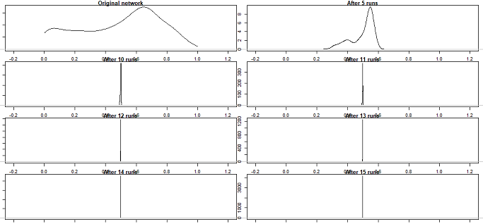

**Figure 3**: An illustration of consensus formation with N=1000, TL=0.3, p=0.1 and μ = 0.5

We conducted similar experiments on various YouTube videos related to COVID-19 vaccine and it provided us an insight into the evolution of users’ polarization over time. We have provided a detailed discussion of these experiments in the next section.

# **Experiments and Results**

## **Process of data preparation**

The primary step in the data preparation process is the selection of YouTube videos related to vaccines that meet the essential and basic criteria i.e., number of comments and relevance to the study. Table – 3 summarizes the videos selected for experimentation.

Now, having established and selected the videos, the next step is the extraction of all vital data pertaining to each of the videos. This step is achieved with the help of a python script and YouTube’s well - integrated **A**pplication **P**rogramming **I**nterface (API). The general interaction or discourse of the viewers with respect to a video is bifurcated into,

Seed Comments – They are referred to as the primary or direct comments a user posts under the comment section of the respective videos.

Secondary Comments – These are referred to as the replies posted to the seed comments by the user.

Establishing the focus point of any study is vital to achieve the best results. Hence, this study focuses mainly on seed comments (by eliminating secondary comments) as it highlights polarizing comments and also evolution of the same with respect to each video. Also, in order to encapsulate the originality of seed comments, the edited original comments are eliminated from the dataset. This marks the cleaning of the dataset for a selected video. The final step of data preparation is the classification of the cleaned dataset into various subsets based on the published dates of the comments. This facilitates a better understanding of polarization and/or consensus formation. Fig. 4 part (a) depicts the entire process of data cleaning.

**Table 3**: COVID-19 vaccine development related YouTube videos on which the experiment was performed

|  |  |  |  |
| --- | --- | --- | --- |
| **Sl. No** | **Title** | **Description** | **Duration** |
| 1 | [The Race to Develop A Coronavirus Vaccine](https://www.youtube.com/watch?v=ek3T8xiu1Fw) | This video briefly explains the spread of coronavirus and how it has affected people’s livelihood. Plus, it also stresses the need for vaccines. Vaccine development for emergency pandemic is not sustainable for investors of a drug company in comparison to the established diseases due to short term requirement. | 10 minutes 14 seconds |
| 2 | [The Coronavirus Vaccine Explained | COVID-19](https://www.youtube.com/watch?v=SSuxVwMkcpA) | This video explains in detail the role and effectiveness of different types of vaccines on a human immune system. Coronavirus strain is explained with the various phases of clinical trials for a vaccine. Also, pinpoints the constraints faced during vaccine development and testing before mass production. | 10 minutes 39 seconds |
| 3 | [The Exciting Covid-19 Vaccine!](https://www.youtube.com/watch?v=lJaR-tkiwV8) | At a testing center in Abu Dhabi, a Chinese-made COVID-19 vaccine (Seal) is in its most crucial stage of clinical trial i.e., phase 3. Various nationals who volunteered for the clinical trials are responding in a positive manner and hence provides hope to the entire world. | 3 minutes 34 seconds |
| 4 | [Bill Gates on How Quickly We Could See A Coronavirus Vaccine | MSNBC](https://www.youtube.com/watch?v=TySmb2_kZj0) | Bill Gates, the co-founder of Microsoft provides a detailed explanation of the timeline for the vaccine to fight against COVID-19. Also, Bill Gates pinpoints the various reasons behind the inefficient testing in the US. | 4 minutes 01 seconds |
| 5 | [WHO on Oxford-AstraZeneca coronavirus vaccine data: It is good news](https://www.youtube.com/watch?v=SDrhQMfQJ6k) | This video shows the WHO personnel applauding a newly published data by the researchers at Oxford university and AstraZeneca on a potential coronavirus vaccine. However, they cautioned that it’s still early days and further evidence of the vaccine’s effectiveness is needed to conclude the research. | 6 minutes 20 seconds |
| 6 | [The risky way to speed up a coronavirus vaccine](https://www.youtube.com/watch?v=r2fxJI_cP58) | This video explains the time stricken (traditional) clinical trial (phase-3) and a controversial model to quicken the process of phase-3 human trial of the COVID-19 vaccine. Human challenge trial and the stages are explained via the help of interviews with epidemiologists and challenge trial volunteers. Also indicates the problems surrounding COVID-19 and human challenge trials. | 9 minutes 12 seconds |

## **Experimental setup**

The cleaned data obtained from the previous step is subjected to sentiment analysis using Microsoft Azure, a text analytical machine learning API available as an add-on in Microsoft Excel. The principal functionality of this API is the ability to arrive at a sentiment score (between 0 and 1) for each comment by using an advanced NLP algorithm. Apart from the sentiment score, Microsoft Azure also labels each comment as positive, negative or neutral. So, finally, the cleaned, segregated (subset based on timestamp) dataset along with the results obtained from Microsoft Azure forms the input dataset in order to run the simulation as explained in the methodology section. Fig. 4 part (b) summarizes the experimental setup.

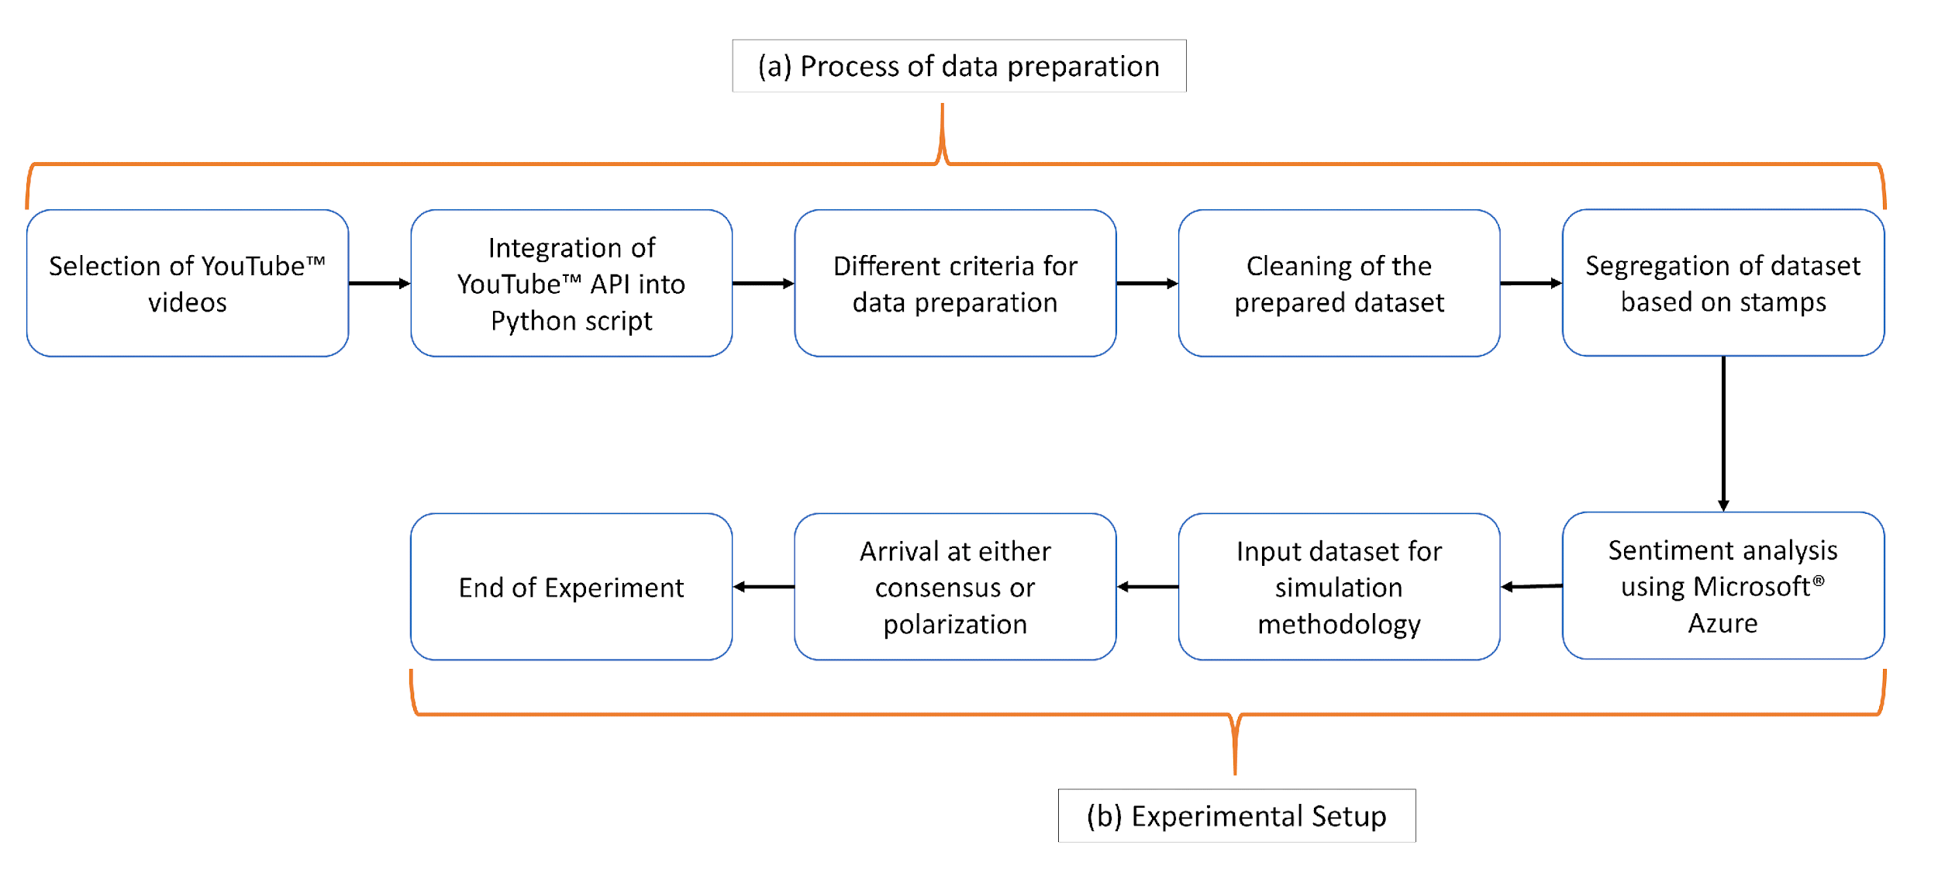

**Figure 4**: Integrated steps showing data preparation and experimental setup

## **Experimental Results**

This section describes the experimental results obtained on the datasets that comprise the subsets of comments of different timestamps. These datasets pertain to the YouTube videos related to the online discourse on the COVID-19 vaccine. The graphical results of the consensus formation dynamics are shown in Figs. 5, 6, 7 for the video captioned as “Bill Gates On How Quickly We Could See A Coronavirus Vaccine | MSNBC”. As shown in Fig. 5, the consensus formation took 13 iterations on the 7072 user comments posted on the video in the third week of May. Similarly, it took 23 iterations to form a consensus on the 91 comments posted in the third week of June and 65 iterations to form a consensus on the 27 comments posted in the third week of July. This result points to a delayed consensus formation as the time goes by and hence shows an increase in the degree of polarization with time.

Table 4 shows the consolidated experimental results on all the YouTube videos related to the discussions around COVID-19 vaccine on which we conducted the experiment. The results demonstrate that the degree of polarization increases with time on various topics related to the development and the availability of COVID-19 vaccine.

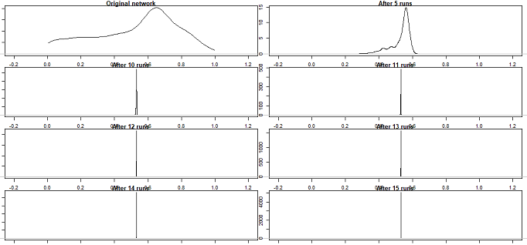

**Figure 5**: Consensus formation on comments during the third week of May

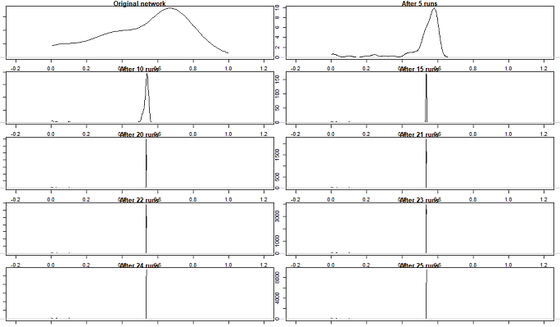

**Figure 6**: Consensus formation on comments during the third week of June

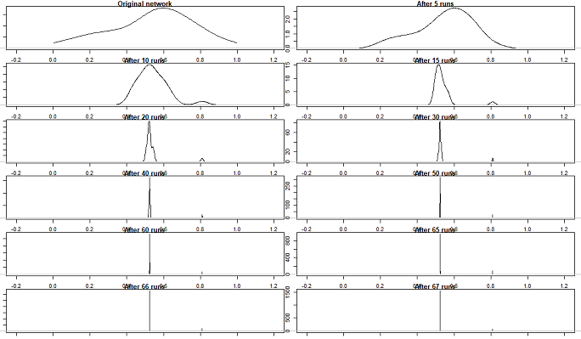

**Figure 7**: Consensus formation on comments during the third week of July

**Table 4**: Experimental results of consensus formation on COVID-19 vaccine development related YouTube videos

|  |  |  |  |
| --- | --- | --- | --- |
| **Videos** | **Time** | **# comments** | **#Iterations for convergence** |
| [The Race To Develop A Coronavirus Vaccine](https://www.youtube.com/watch?v=ek3T8xiu1Fw) | Third week of April | 3207 | 13 |
| Third week of May | 812 | 17 |
| Third week of June | 29 | 80 |
|  | | | |
| [The Coronavirus Vaccine Explained | COVID-19](https://www.youtube.com/watch?v=SSuxVwMkcpA) | Third week of May | 3401 | 13 |
| Third week of June | 49 | 25 |
| Third week of July | 25 | 70 |
|  | | | |
| [The Exciting Covid-19 Vaccine!](https://www.youtube.com/watch?v=lJaR-tkiwV8) | Third week of August | 8486 | 12 |
| Third week of September | 1455 | 13 |
| Fourth week of September | 45 | 30 |
| First week of October | 52 | 45 |
|  | | | |
| [Bill Gates On How Quickly We Could See A Coronavirus Vaccine | MSNBC](https://www.youtube.com/watch?v=TySmb2_kZj0) | Third week of June | 7072 | 13 |
| Third week of July | 91 | 23 |
| Third week of August | 27 | 65 |
|  | | | |
| [WHO on Oxford-AstraZeneca coronavirus vaccine data: It is good news](https://www.youtube.com/watch?v=SDrhQMfQJ6k) | First week of August | 491 | 12 |
| First week of September | 33 | 60 |
|  | | | |
| [The risky way to speed up a coronavirus vaccine](https://www.youtube.com/watch?v=r2fxJI_cP58) | First week of August | 1134 | 10 |
| First week of September | 392 | 11 |

# **Discussion**

Our selection of the YouTube videos to conduct experiments was based on our objective to capture as much variation as possible in the online public discourse related to the development of COVID-19 vaccine and the associated controversies around that. For example, we chose one of the videos which talks about the chaos that COVID-19 has caused in the global economy where companies are forced to freeze their supply chains, ask employees to permanently work from home, and ban all global or domestic travel. The video also discusses how fast the countries, especially the US, have mobilized their resources to develop a vaccine. Despite a huge market for vaccines, vaccine development for emergency situations like disease outbreaks is usually not seen as a good business opportunity by the pharmaceutical industry as the vaccine is planned to be used for a shorter duration of time in such situations. The video also shows the medical fraternity talking about the different phases of the trial and the ethical, medical and other considerations associated with the trials so as to be sure that it is safe to vaccinate the normal public. The comments initially posted on this video blame the companies for linking the development of the vaccine with a business opportunity rather than doing it for the public good. With time, we observed a shift in users’ behavior when they started raising doubts over the coronavirus genome sequence developed by the Chinese and the discourse became more polarized. Spread of misinformation around the genome sequence, which acts as an input in the vaccine development process, is partly to blame for this increased polarization. Another video that we chose for our experiment features an interview with Bill Gates, cofounder of Microsoft and the Bill and Melinda Gates foundation, on how quickly we could see a coronavirus vaccine. Bill talks about how an investment of billions of dollars in vaccine development could save a potential loss of trillions of dollars caused due to lockdowns etc. When asked about his assessment on how the US has done in terms of testing and what could have been better, he mentions that the access to testing is chaotic even though the testing capacity has gone up. Users who commented on this video seem to be frustrated for a few reasons, such as a person not related to the medical field discussing the availability of the vaccine and success of the public health policies. Users also casted doubts on whether Bill has some hidden agenda as he is an investor in many pharmaceutical companies, some of which are in the race to develop a vaccine for COVID-19. While the general response to this video was negative towards the start, few users also supported Bill’s point of view as the time went by. This is evident from the increased polarization that was seen among the users who commented on this video. Similarly, the other videos that we used for our experiments garnered unusual responses from the users and hence depict a very different online social behavior during a pandemic situation and thus induce polarization in the society.

One interesting observation from this study is that the polarization among the social media users on a COVID-19 vaccine related video increases with time. As the time goes by, a larger number of iterations taken to form a consensus demonstrates this outcome. One of the reasons we consider this observation as significant in the study of social media polarization, particularly around topics that lead to a political debate and COVID-19 vaccination is one of such topics, is that it is still a highly contested debate whether the flow of information on social media fosters or counteracts polarization (Kligler-Vilenchik, Baden and Yarchi 2020). There are studies that suggest that the selective exposure in echo chambers may lead users to falsely construe the available information and majority opinion to reinforce their own beliefs and interpretations by which they consider increasingly extreme positions (Müller et al. 2017; Wojcieszak 2011; Gaffney et al. 2013). On the contrary, some recent studies suggest that as the users regularly get exposed to opposing opinions on the social media, the homophilic effect in their network gets weakened by this cross-cutting exposure with time (Yardi and Boyd 2010). Various studies (Garimella et al. 2017; Garimella et al. 2017) have been conducted to study how the polarization in social media can be reduced by balancing information exposure and connecting the opposing views. Thus, our experimental outcome that shows an increase in users’ polarization with time, when they participate in a public discourse on a COVID-19 vaccine related topic on social media (YouTube in our case), contributes to the wider ongoing research around the social media induced polarization (SMIP).

There could be a few possible explanations of this phenomenon. One could be that the online social media users who have extreme views on any topic continue to comment on the videos while the users with moderate to neutral views lose interest to comment with time. This explanation is also corroborated by a decrease in the number of comments on the videos as the recency of the discourse increases (shown in Table 4). Another explanation is related to the evolution of the opinions in the adaptive networks, where two users reach a consensus when there is a path of users in between them, each having their opinion within the tolerance limit of the previous user’s opinion (Kozma and Barrat 2008). Having a larger number of comments presents a higher possibility of getting such a path between two users in a network and hence it takes a smaller number of iterations to form a consensus. However, our observation of increased polarization with time on COVID-19 vaccine related videos on YouTube still holds true despite the explanations above.

# **Conclusion**

Our study suggests that the social media induced polarization on the discussion around COVID-19 vaccine has increased over time. This observation is contrary to the findings of the previous studies on polarization around socio-cultural issues which suggest a decrease in social media induced polarization over time (Amendola, Marra and Quartin 2015). Alternatively, studies conducted on Facebook users who belong to pro-vaccine and anti-vaccine communities suggest that the anti-vaccination group consumes more coherent sources with their views and has a more cohesive growth (i.e., pages liked by the same people) than the pro-vaccine groups (Schmidt et al. 2018). This echo chamber effect may eventually give rise to vaccine hesitancy, and the social media campaigns that advocate the importance of vaccination may only reach the pro-vaccination groups (Schmidt et al. 2018). Our study strengthens the view that as time goes by, social media fosters polarization among the users. However, our observations are limited to the users who commented on the COVID-19 vaccine-related YouTube videos selected for our study.

Predominantly around the COVID-19 vaccine debate, the inability of the countries, including that of the developed nations, to control the outbreak has triggered a greater interest in the discovery of a vaccine and this could be a potential reason for why the society is becoming more polarized around this topic. Political establishments of various countries have promised a free vaccination of COVID-19 for all if they are voted to power. This use of COVID-19 vaccine to gain a political mileage is one of the major causes of polarization in the society[19]. One of the possible use cases of this study is to minimize the societal divide around the availability of the cure during pandemics. Government and healthcare agencies of various countries could intervene as soon as possible to curb the spread of misinformation on social media by running online social awareness campaigns that are targeted to reach anti-vaccination communities, thus making people aware of the ill-effects of falling prey to the fake news around the cure and the discovery of a vaccine.

While we have tried to capture the dynamics of opinion formation on a diverse set of YouTube videos that are related to the development of COVID-19 vaccine, our work has its own limitations. Our first limitation is the use of Azure sentiment analysis methodology which doesn’t consider the contextual polarity of a word. Our second limitation is that the possible impact of user’s polarization around one YouTube video on the opinion of the users of other YouTube videos is not considered i.e. all the YouTube videos are considered independent of each other. In addition to this, we also don’t have a prior knowledge of the users’ connections with each other to establish the effect of homophily and interdependence on the starting state of our network. Lastly, we have only considered YouTube videos for our experiments and hence our findings are limited to just a single social media platform.

This study could open several interesting directions for future work. One would be to increase the scope of this work to include the study of opinion dynamics around the economic impact of the lockdowns during COVID-19. Secondly, the study of polarization on other social media platforms (such as Twitter and Facebook) may provide some useful insights into how the opinions of the users evolve over time during pandemics.

# **References**

### Albert, R. and Barabási, A.-L. (2002). Statistical mechanics of complex networks. Rev. Mod. Phys. 74, 47 (2002).

1. Allcott, H., Boxell, L., Conway, J. C., Gentzkow, M., Thaler, M. and Yang, D. Y. (2020). Polarization and Public Health: Partisan differences in social distancing during the coronavirus pandemic. National Bureau of Economic Research. Working Paper No. 26946
2. Amendola, L., Marra, V., and Quartin, M. (2015). The evolving perception of controversial movies. Palgrave Communications, 1(1), 1-9.
3. American College of Physicians. (2019). No link found between MMR vaccine and autism, even among children with other risk factors for autism. ScienceDaily.
4. Antona, D., Lévy-Bruhl,, D., Baudon, C., Freymuth, F., Lamy, M., Maine, C., . . . Parent du Chatelet, I. (2013). Measles Elimination Efforts and 2008–2011 Outbreak, France. Emerging Infectious Diseases, 357-364.
5. Asaria, P., and MacMahon, E. (2006). Measles in the United Kingdom: can we eradicate it by 2010? *BMJ. Vol. 333. Group: British Medical Journal Publishing*, 890–895.
6. Bail, C. A., Argyle, L. P., Brown, T. W., Bumpus, J. P., Chen, H., Hunzaker, M., Volfovsky, A. (2018). Exposure to opposing views on social media can increase political polarization. Proceedings of the National Academy of Sciences, 9216-9221
7. Barua, Z., Barua, S., Akta, S., Kabir, N., and Li, M. (2020). Effects of misinformation on COVID-19 individual responses and recommendations for resilience of disastrous consequences of misinformation. Progress in Disaster Science, 1-2.
8. Basch, C. H. and MacLean, S. A. (2019). A content analysis of HPV related posts on instagram. Human Vaccines and Immunotherapeutics, 15:7-8, 1476-1478.
9. Basch, C. H., Zybert, P., Reeves, R. and Basch, C E. (2017). What do popular YouTube videos say about vaccines? Child: care, health and development. Wiley Online Library. Doi:10.1111/cch.12442.
10. Ben-Naim, E., Krapivsky, P. L., Redner, S. (2004). Bifurcations and Patterns in Compromise Processes. Physica D 183, 190.
11. Benecke, O., and DeYoung, S. E. (2019). Anti-Vaccine Decision-Making and Measles Resurgence in the United States. Glob Pediatr Health, 1-2.
12. Blankenship, E. B., Goff, M. E., Yin, J., Tse, Z., Fu, K. W., Liang, H., Saroha, N., and Fung, I. C. (2018). Sentiment, Contents, and Retweets: A Study of Two Vaccine-Related Twitter Datasets. The Permanente journal, 22, 17–138.
13. Brugnoli, E., Cinelli, M., Quattrociocchi, W., and Scala, A. (2019). Recursive patterns in online echo chambers. Scientific Reports, 1-2.
14. Castellano, C., Loreto, V., Barrat, A., Cecconi, F. and Parisi, D. (2005). Comparison of voter and Glauber ordering dynamics of networks. Phys. Rev. E 71, 066107 (2005).
15. Cossard, A., De Francisci Morales, G., Kalimeri, K., Mejova, Y., Paolotti, D., and Starnini, M. (2020). Falling into the Echo Chamber: The Italian Vaccination Debate on Twitter. Proceedings of the Fourteenth International AAAI Conference on Web and Social Media, 1-2.
16. Cranmer, S. J., Leifeld, P., McClurg, S. D., and Rolfe, M. (2017). Navigating the range of statistical tools for inferential network analysis. American Journal of Political Science, 61(1), 237-251.
17. D. Yilma, T., Leslie, A., and Paulo, H. (2004). Genetic Engineering of Vaccines. International Laboratory of Molecular Biology for Tropical Disease Agents, 295-297.
18. Deffuant, G., Neau, D., Amblard, F., and Weisbuch, G. (2000). Mixing beliefs among interacting agents. Advances in Complex Systems, 3(01n04), 87-98.
19. Del Vicario, M., Scala, A., Caldarelli, G., Eugene Stanley, H. and Quattrociocchi, W. (2017). Modeling confirmation bias and polarization. Scientific reports 7, 40391.
20. Depoux A, Martin S, Karafillakis B, Preet R, Wilder-Smith A, Larson H. The pandemic of social media panic travels faster than the COVID-19 outbreak. J Travel Med. 2020; 27: taaa031.
21. Donovan, J. (2020). Social-media companies must flatten the curve of misinformation. Europe PMC. Nature, PMID: 32291410
22. Dorogovtsev, S. N. and Mendes, J. F. F. (2003). Evolution of networks: From biological nets to the Internet and WWW (Oxford University Press, Oxford, 2003).
23. Dorogovtsev, S. N. and Mendes, J. F. F. (2002). Evolution of networks. Adv. Phys. 51, 1079 (2002).
24. Flaherty, D. K., (2011). The vaccine-autism connection: a public health crisis caused by unethical medical practices and fraudulent science. The Annals of Pharmacotherapy, 45 (10), 1302–1304
25. Fredrickson, M. M., and Chen, Y. (2019). Permutation and randomization tests for network analysis. Social Networks, 59, 171-183.
26. Gaffney, A. M., Rast, I. I. I., Hackett, J. D., Hogg, M. A. (2013). Further to the right: Uncertainty, political polarization and the American “Tea Party” movement. Social Influence, 9(4), 272–−288.
27. Galam, S., Gefen, Y. and Shapir, Y. (1982). Sociophysics: A new approach of sociological collective behaviour. I. mean-behaviour description of a strike. The Journal of Mathematical Sociology, volume 9 issue 1.
28. Garimella, K., Gionis, A., Parotsidis, N., and Tatti, N. (2017). Balancing information exposure in social networks. In Advances in Neural Information Processing Systems (pp. 4663-4671).
29. Garimella, K., Morales, G. D., Gionis, A. and Mathioudakis, M. (2017). Reducing Controversy by Connecting Opposing Views. WSDM '17: Proceedings of the Tenth ACM International Conference on Web Search and Data Mining (Pages 81–90).
30. Glauber, R. J. (1963). Time-Dependent Statistics of the Ising Model. Journal of Mathematical Physics 4,294.
31. Godlee, F., Smith, J., and Marcovitch, H. (2011). Wakefield's article linking MMR vaccine and autism was fraudulent. BMJ: British Medical Journal, 64-66.
32. Hussain, A., Ali, S., Ahmed, M., and Hussain, S. (2018). The Anti-vaccination Movement: A Regression in Modern Medicine. Cureus, 1-8.
33. Jin, C., Li, Y., and Jin, X. (2017). Political opinion formation: Initial opinion distribution and individual heterogeneity of tolerance. Physica A: Statistical Mechanics and its Applications, 467, 257-266.
34. Ju, C., Wang, J., and Shi, J. (2020). The intelligent method of public opinion polarisation modelling and simulation analysis based on multi-dimensional and multi-level evaluation. Behaviour and Information Technology, 1-13.
35. Justwan, F., Baumgaertner, B., Carlisle, J. E., Clark, A. K., and Clark, M. (2018). Social media echo chambers and satisfaction with democracy among Democrats and Republicans in the aftermath of the 2016 US elections. J Elect Public Opin Parties, 424–442.
36. Khan, S., Faslu Rahman, C. K., Haritha, C. V., Jose, B., Tiwari, R., Dhama, K. (2020). COVID-19 Vaccine Acceptance: Beliefs and Barriers associated with Vaccination among the General Population in India. Journal of Experimental Biology and Agricultural Sciences. Volume-8 (Spl-1-SARS-CoV-2), pp 210-218.

1. Kligler-Vilenchik, N., Baden, C. and Yarchi, M. (2020). Interpretative Polarization across Platforms: How Political Disagreement Develops Over Time on Facebook, Twitter and WhatsApp. Social Media+Society, Volume: 6 Issue: 3.
2. Kozma, B., and Barrat, A. (2008). Consensus formation on adaptive networks. Physical Review E, 77(1), 016102.
3. Krackhardt, D. (1988). Predicting with networks: Nonparametric multiple regression analysis of dyadic data. Social networks, 10(4), 359-381.
4. Krapivsky, P. L. and Redner, S. (2003). Dynamics of Majority Rule in Two-State Interacting Spin Systems. Physical Review Letter 90. 238701.
5. Laato, S., Islam, A. K. M. N., Islam, M. N., and Whelan, E. (2020). What drives unverified information sharing and cyberchondria during the COVID-19 pandemic? European Journal of Information Systems, 29:3, 288-305, DOI: 10.1080/0960085X.2020.1770632
6. Li, H. O., Bailey, A., Huynh, D. and Chan, J. (2020). YouTube as a source of information on COVID-19: a pandemic of misinformation? BMJ Global Health;5: e002604.
7. Lin, Y., Hu, Z., Zhao, Q., Alias, H., Danaee, M., and Wong, L. (2020). Understanding COVID-19 vaccine demand and hesitancy: A nationwide online survey in China. PLOS Neglected Tropical Diseases.
8. Lin, Y., Hu, Z., Zhao, Q., Alias, H., Danaee, M., and Wong , L. (2020). Understanding COVID-19 vaccine demand and hesitancy: A nationwide online survey in China. PLOS Neglected Tropical Diseases
9. Müller, P., Schemer, C., Wettstein, M., Schulz, A., Wirz, D. S., Engesser, S. and Wirth, W. (2017). The polarizing impact of news coverage on populist attitudes in the public: Evidence from a panel study in four European democracies. Journal of Communication, 67(6), 968–992.
10. Newman, M. E. J. (2003). The Structure and Function of Complex Networks. SIAM Rev., 45(2), 167–256.
11. Ortiz-Sánchez, E., Velando-Soriano, A., Pradas-Hernández, L., Vargas-Román, K., Gómez-Urquiza, J. L., Cañadas-De la Fuente, G. A., and Albendín-García, L. (2020). Analysis of the Anti-Vaccine Movement in Social Networks: A Systematic Review. International journal of environmental research and public health, 17(15), 5394. https://doi.org/10.3390/ijerph17155394
12. Papakyriakopoulos, O., Medina Serrano, J. C., Hegelich, S. (2020). The spread of COVID-19 conspiracy theories on social media and the effect of content moderation. The Harvard Kennedy School (HKS) Misinformation Review, Volume 1, Special Issue on COVID-19 and Misinformation. https://doi.org/10.37016/mr-2020-033
13. Pastor-Satorras, R. and Vespignani, A. (2004). Evolution and structure of the Internet: A statistical physics approach (Cambridge University Press, Cambridge, 2004).
14. Pepys, M. B. (2007). Science and serendipity. Clinical medicine (London, England), 562-578.
15. Phuong, T. T., Nguyen, D. C., Nguyen, A. T., Nguyen, L. H., Vu, G. T., Nguyen, C. T., Le, H. T. (2020). Fake News Affecting the Adherence of National Response Measures During the COVID-19 Lockdown Period: The Experience of Vietnam. Front. Public Health.
16. Puri, N., Coomes, E. A., Haghbayan, H. and Gunaratne, K. (2020). Social media and vaccine hesitancy: new updates for the era of COVID-19 and globalized infectious diseases. Human Vaccines and Immunotherapeutics, 16:11, 2586-2593.
17. Rao, T., and Andrade, C. (2011). The MMR vaccine and autism: Sensation, refutation, retraction, and fraud. Indian J Psychiatry, 95-96.
18. Robins, G., Lewis, J. M., and Wang, P. (2012). Statistical network analysis for analyzing policy networks. Policy Studies Journal, 40(3), 375-401.
19. Romer, D., Jamieson, K. H. (2020). Conspiracy theories as barriers to controlling the spread of COVID-19 in the US. Social Science and Medicine. Elsevier, Volume 263, 113356.
20. Ross, D. L. (1968). Leicester and the anti-vaccination movement, 1853-1889. Trans Leicester Archaeol Hist Soc., 35-44.
21. S. Mitchell, V., M. Philipose, N., and P. Sanford, J. (1993). The Children's Vaccine Initiative. National Academy Press.
22. Sasahara, K., Chen, W., Peng, H., Ciampaglia, G. L., Flammini, A., and Menczer , F. (2020). Social influence and unfollowing accelerate the emergence of echo chambers. Journal of Computational Social Science, 1-3.
23. Schmidt, A., Zollo, F., Scala, A., Betsch, C., and Quattrociocchi, W. (2018). Polarization of the vaccination debate on Facebook. Elsevier, 3606.
24. Shahsavari, S., Holur, P., Wang, T., Tangerine, T. R., and Roychowdhury , V. (2020). Conspiracy in the time of corona: automatic detection of emerging COVID-19 conspiracy theories in social media and the news. Journal of Computational Social Science, 279-317.
25. Simms, K. T., Hanley, S. J., Smith, M. A., Keane, A., and Canfell, K. (2020). Impact of HPV vaccine hesitancy on cervical cancer in Japan: Lancet Public Health, 223-224
26. Sood, V. and Redner, S. (2005). Voter Model on Heterogenous Graphs. Phys. Rev. Lett. 94, 178701 (2005).
27. Stanley, P. (2014). History of vaccination. Proceedings of the National Academy of Sciences of the United States of America, 12283–12287.
28. Ulvi, O., Lippincott, N., Khan, M. H., Mehal, P., Bass, M., Lambert, K., Haque, U. (2019). The role of social and mainstream media during storms. Journal of public health and emergency, 2-4.
29. Wakefield, A. J. (1999). MMR vaccination and autism (Vol. 354). The Lancet. https://doi.org/10.1016/S0140-6736(05)75696-8
30. Wilson, M. E., and Chen, L. H. (2020). Travellers give wings to novel coronavirus (2019-nCoV). Journal of travel medicine, 27(2), taaa015. https://doi.org/10.1093/jtm/taaa015
31. Wojcieszak, M. E. (2011). Computer-mediated false consensus: Radical online groups, social networks and news media. Mass Communication and Society, 14(4), 527–546.
32. Yardi, S., Boyd, d. (2010). Dynamic debates: An analysis of group polarization over time on Twitter. Bulletin of Science, Technology and Society, 30(5), 316–327.

# **Appendix 1**

Sensitivity analysis results of the convergence parameter *µ* showing that the consensus formation gets delayed as *µ* increases but the end result remains the same:

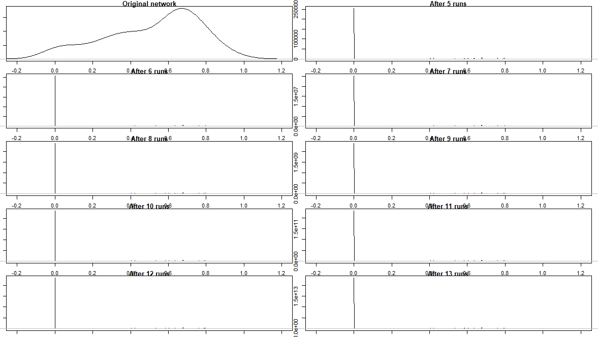

**Figure 8**: µ = 0.1, Number of comments=91, Consensus formation in 6 iterations

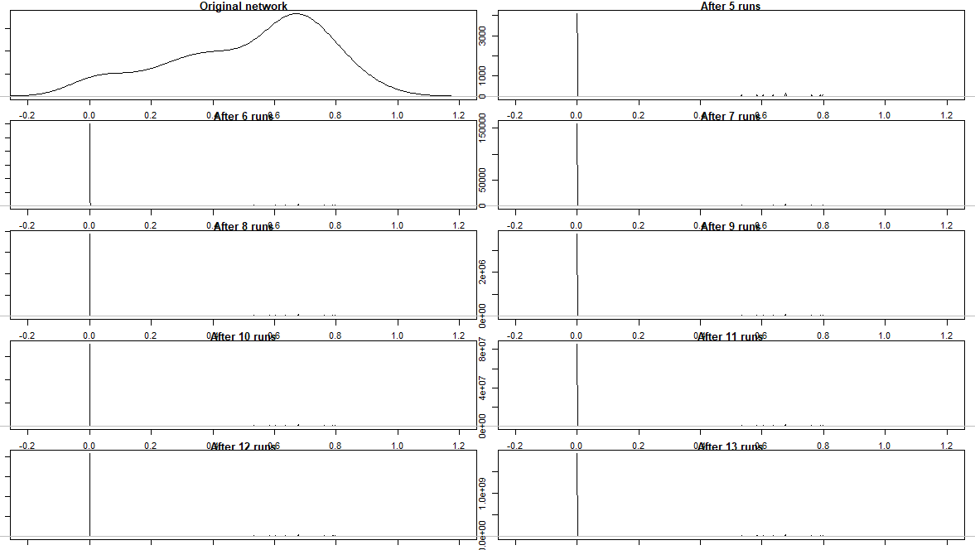

**Figure 9**: µ = 0.2, Number of comments=91, Consensus formation in 6 iterations

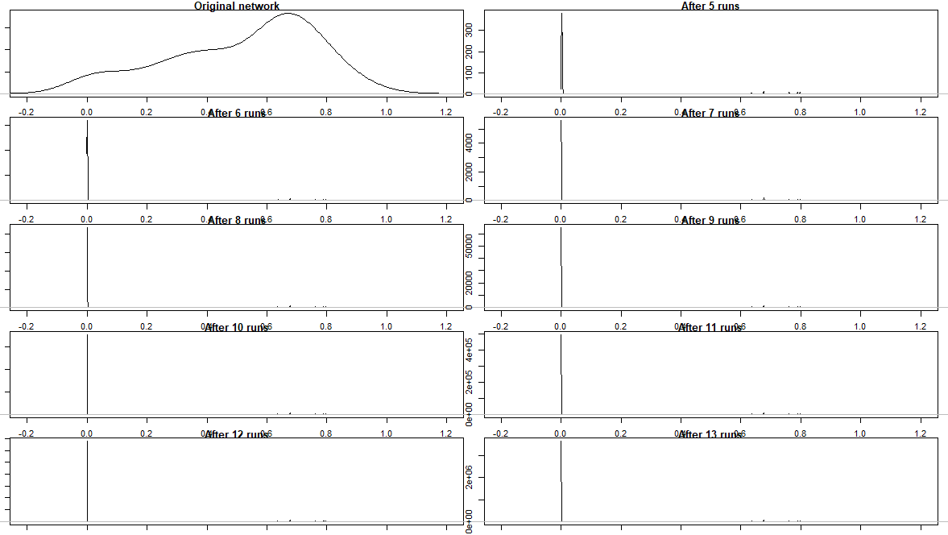

**Figure 10**: µ = 0.3, Number of comments=91, Consensus formation in 7 iterations

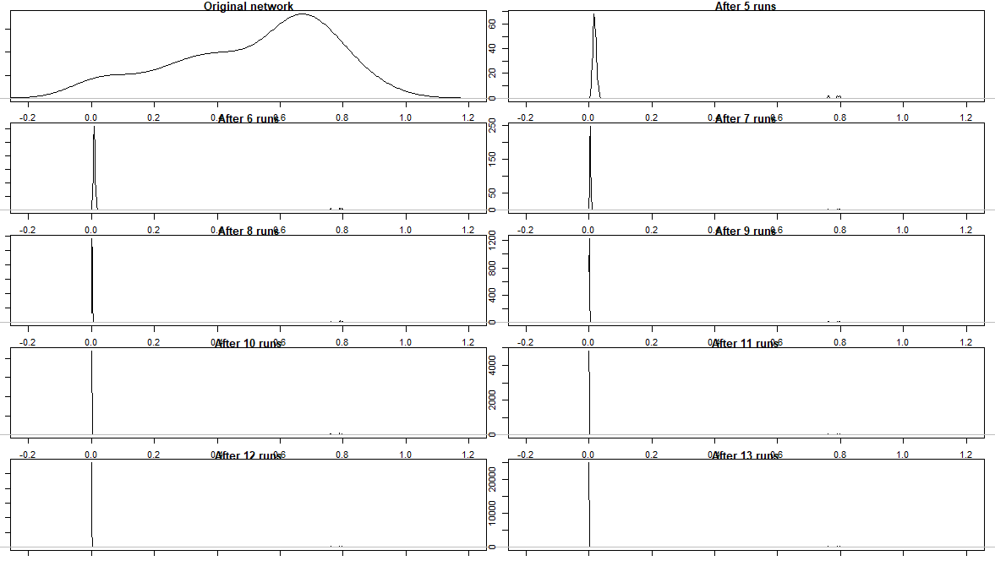

**Figure 11**: µ = 0.4, Number of comments=91, Consensus formation in 10 iterations

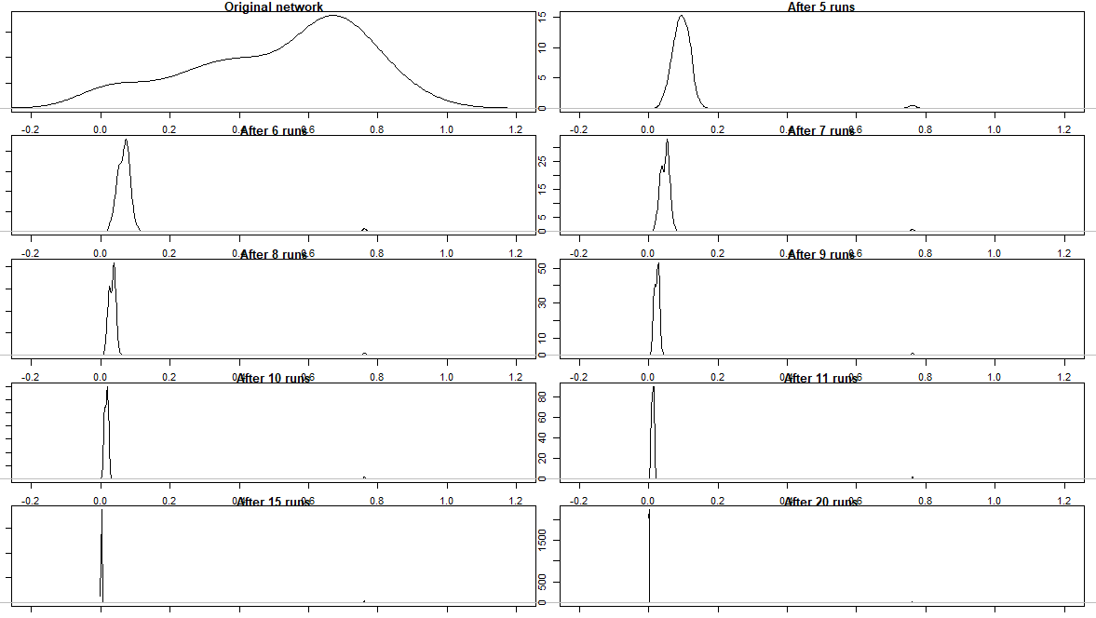

**Figure 12**: µ = 0.5, Number of comments=91, Consensus formation in 20 iterations

1. <https://www.un.org/en/un-coronavirus-communications-team/un-tackling-%E2%80%98infodemic%E2%80%99-misinformation-and-cybercrime-covid-19>
2. <https://www.theatlantic.com/technology/archive/2018/08/how-misinfodemics-spread-disease/568921/>
3. <https://www.vox.com/policy-and-politics/2020/3/12/21177135/coronavirus-covid-19-pandemic-trump-biden-speeches>
4. Samajwadi Party is a political party in India headquartered in New Delhi.
5. BJP- The Bharatiya Janata Party is one of two major political parties in India, along with Indian National Congress. It has been the ruling political party of the Republic of India since 2014
6. <https://www.nytimes.com/2020/12/18/us/politics/trump-vaccine-skeptics.html>
7. <https://www.healio.com/news/pediatrics/20120325/wakefield-study-linking-mmr-vaccine-autism-uncovered-as-complete-fraud>
8. https://backlinko.com/social-media-users
9. https://influencermarketinghub.com/what-is-an-influencer/https://influencermarketinghub.com/what-is-an-influencer/
10. https://www.hollywoodreporter.com/news/jessica-biels-vaccine-lobbying-draws-ire-california-legislators-1218309
11. https://trackbill.com/bill/california-senate-bill-276-immunizations-medical-exemptions/1688024/
12. https://www.instagram.com/jessicabiel/?hl=en
13. https://www.theguardian.com/technology/2020/apr/20/facebook-anti-lockdown-protests-bans
14. https://www.vox.com/the-goods/2020/8/7/21357400/anti-mask-protest-rallies-donald-trump-covid-19
15. https://www.telegraph.co.uk/news/2020/12/02/take-anti-vaccine-conspiracy-posts-face-consequences-ministers/
16. https://news.harvard.edu/gazette/story/2020/05/social-media-used-to-spread-create-covid-19-falsehoods/
17. Smaller values of TL (0.1,0.2) revealed that the network almost never evolve to a consensus. Alternatively, larger values of TL (0.4,0.5,0.6) didn’t provide any meaningful insights as a broader level consensus was formed.
18. https://www.youtube.com/watch?v=ek3T8xiu1Fw
19. <https://www.republicworld.com/india-news/politics/after-slamming-bjp-in-bihar-congress-govt-in-puducherry-announces-free-covid-vaccine.html>